**BUDHANILKANTHA SECONDARY SCHOOL**

**Budhanilkantha -3, Kathmandu**



**Lab Report of Computer Networking**

**Submitted by: Submitted to:**

**Name**: Dhirendra Kathayat **Subject Teacher**

**Roll no.:** 07

**Signature: _________________**

**Installation of CISCO packet Tracker in windows:**

Follow the below steps to install Packet Tracer on Windows:

**Step 1: Use any web browser to see the Netacad official website.**

**Step 2:**Press the login button and select log In option.

**Step 3:**Next screen will appear, click on the sign-up option.

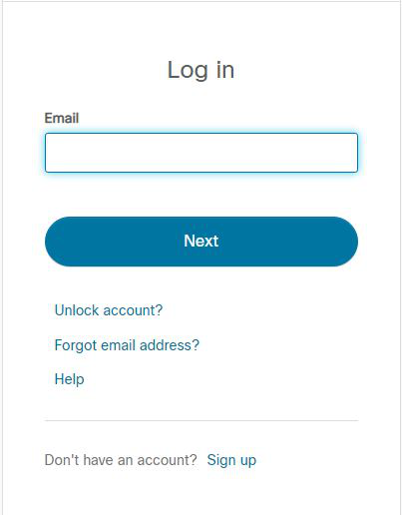

**Step 4:** Next screen will appear and will ask for email and password and other simple details, fill them and click on Register.

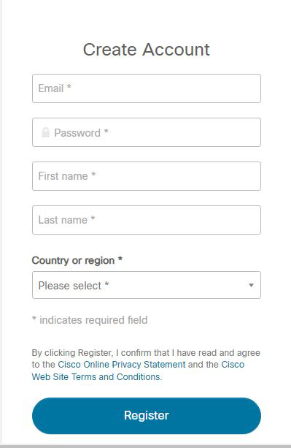

**Step 5:**Now the login screen appears again so fill in the Email id.

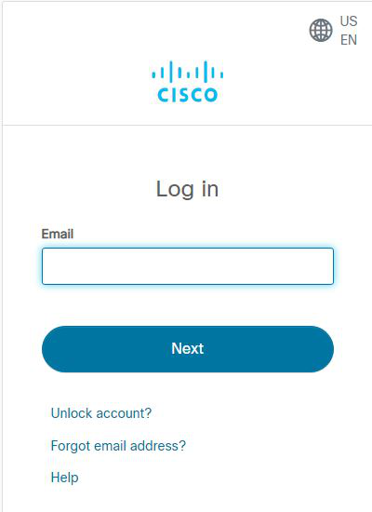

**Step 6:**On the next screen enter the password and press the Login button.

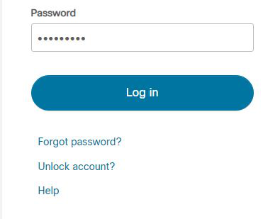

**Step 7:**Dashboard will initialize, now click on Resources and choose Download Packet Tracer Option.

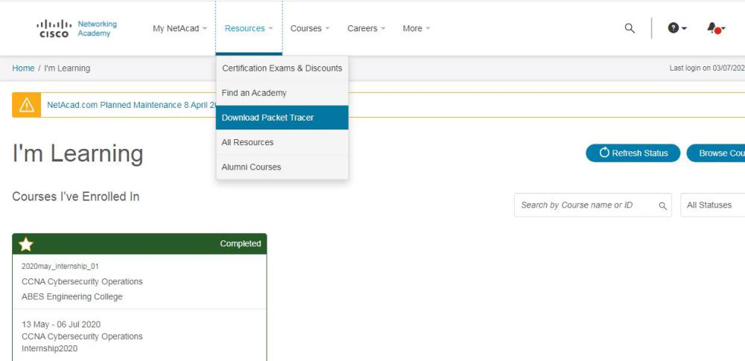

**Step 8:**On the next web page choose the operating system to download the packet tracer. Downloading will start automatically.

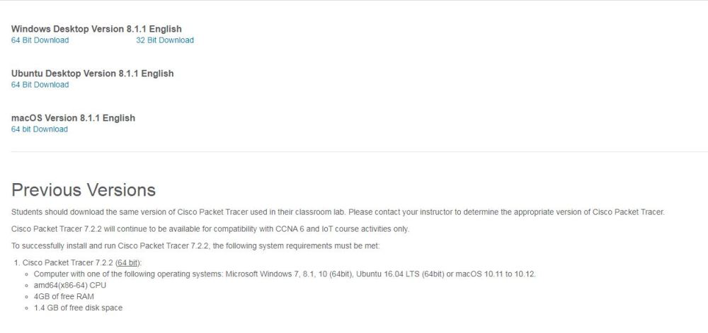

**Step 9:**Check for the executable file in your system and run it.

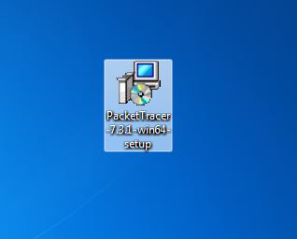

**Step 10:**Next screen is of License Agreement so Click on **I accept** the license.

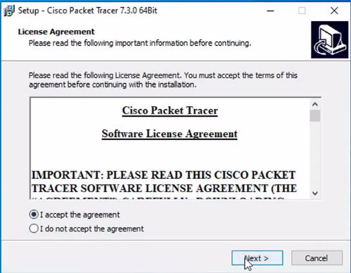

**Step 11:**Choose the installing location which has sufficient space.

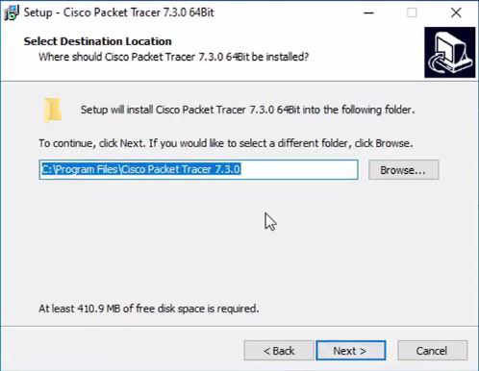

**Step 12:** Select the start menu folder and click the **Next** button.

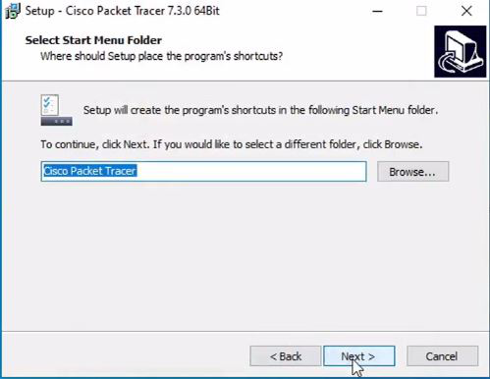

**Step 13:**Check the box for creating a desktop icon and click on the **Next** button

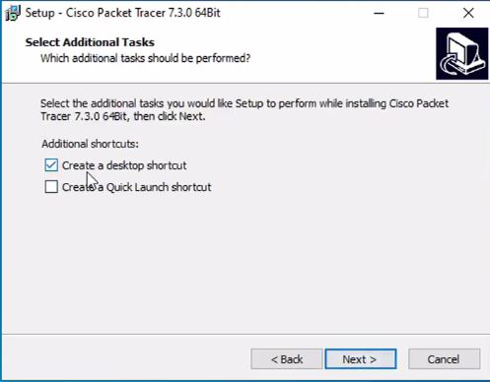

**Step 14:** Now packet tracer is ready to install so click on the **Install**button.

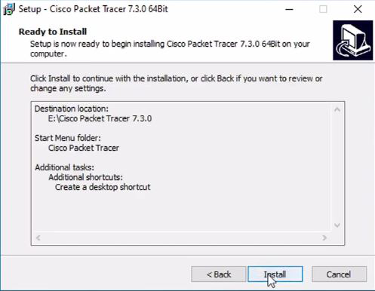

**Step 15:**The installation process will start and will hardly take a minute.

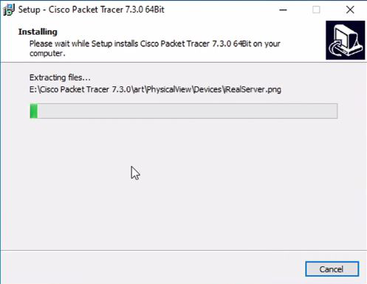

**Step 16:**Click on the **Finish** button to complete the installation.

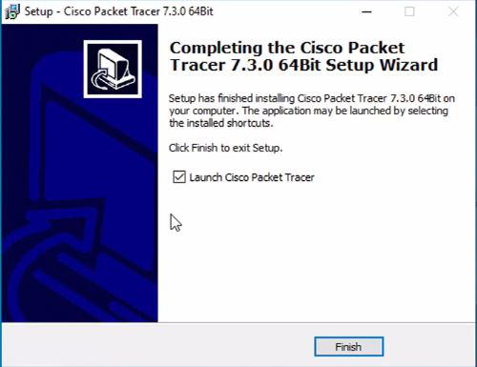

**Step 17:**An icon is created on the desktop so run it.



**Step 18:** Interface is initialized and the software is ready to use.

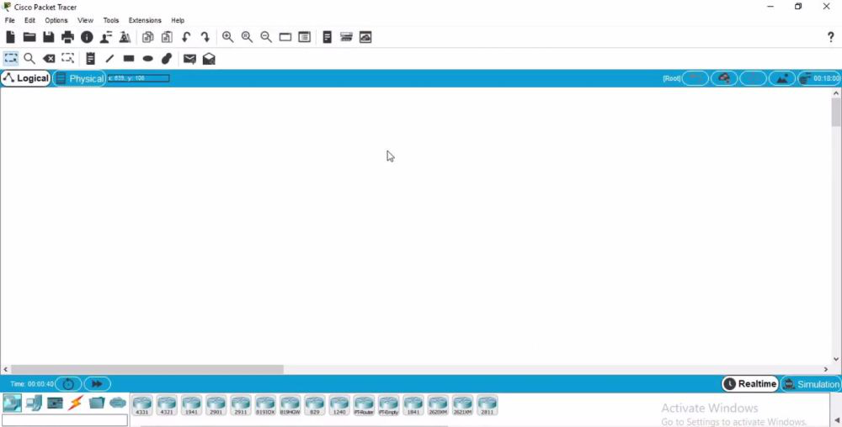

**LAB CISCO DESCRIPTION OF P2P NETWORK:**

**Peer to peer Network:**

A peer-to-peer (P2P) network is a decentralized network architecture in which participants, referred to as peers, can directly interact with each other without the need for a central server or authority. In a P2P network, each participant can act both as a client and a server, allowing for the sharing of resources, services, or information among the peers.

In a traditional client-server model, requests are made to a central server, which then responds and fulfills those requests. However, in a peer-to-peer network, the participants have equal capabilities and can directly communicate with each other, sharing and exchanging data or services without relying on a central entity.

P2P networks are often used for file sharing, where users can access and download files from other users' computers directly. Each peer in the network can contribute its own resources, such as bandwidth, storage space, or processing power, making the network more robust and scalable.

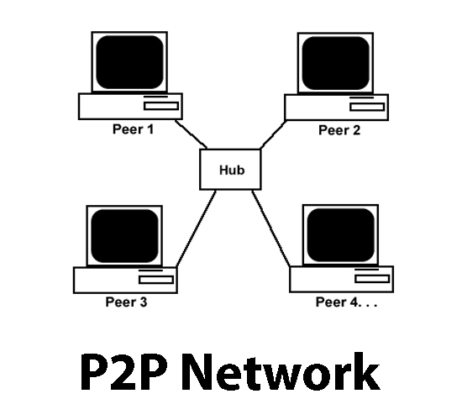

**CISCO DESCRIPTION OF P2P NETWORK:**

In Cisco Packet Tracer, a peer-to-peer network can be simulated by connecting multiple devices together without the presence of a central server. Each device in the network, such as computers, laptops, or routers, can be represented as a node or device icon in the Packet Tracer workspace.

To simulate a P2P network in Cisco Packet Tracer, you can connect the devices directly to each other using appropriate cables or wireless connections. This represents the direct communication between peers in a P2P network, where they can share resources, exchange data, or provide services to each other without relying on a central server.

For example, you can connect two computers directly using an Ethernet cable or a wireless connection in Cisco Packet Tracer. This allows the computers to communicate with each other, share files, or collaborate on tasks without the need for a central server. You can also configure the network settings of each device, such as IP addresses, subnet masks, and default gateways, to ensure proper communication within the P2P network.

Cisco Packet Tracer provides a visual representation of the P2P network, allowing you to observe the connections between devices and simulate the flow of data or network traffic. You can also configure various network protocols and services, such as file sharing protocols or peer discovery mechanisms, to further enhance the simulation and understand the behavior of a P2P network.

Overall, Cisco Packet Tracer can be used to simulate and visualize the workings of a peer-to-peer network, enabling users to understand the concepts and principles behind P2P communication and explore its applications in a virtual networking environment.

**LAB COMPUTER CONNECTION AND P2P FILE SHARING:**

In a lab environment, we can establish a direct connection between two computers using a crossover cable, enabling the sharing of files between them. This setup represents a peer-to-peer (P2P) network where the computers act as equal participants without the need for a central server.

Using a crossover cable, which has specific wiring to facilitate direct communication between two devices, we can connect the Ethernet ports of the two lab computers. This cable eliminates the need for a network switch or router, allowing the computers to establish a direct connection.

Once the computers are connected via the crossover cable, we can configure their network settings. Each computer should be assigned a unique IP address within the same subnet, along with the appropriate subnet mask. This ensures that they are on the same network and can communicate with each other.

With the physical and network connections established, we can proceed to share files between the lab computers. This can be done through various methods such as enabling file sharing on both computers, creating shared folders, or using specific file sharing protocols.

For example, in this P2P setup, the lab computers can directly communicate and transfer files between each other, leveraging the simplicity and convenience of a direct connection. This eliminates the need for external storage devices or network infrastructure, making it an efficient solution for file sharing in a controlled lab environment.